PRACTICAL 2
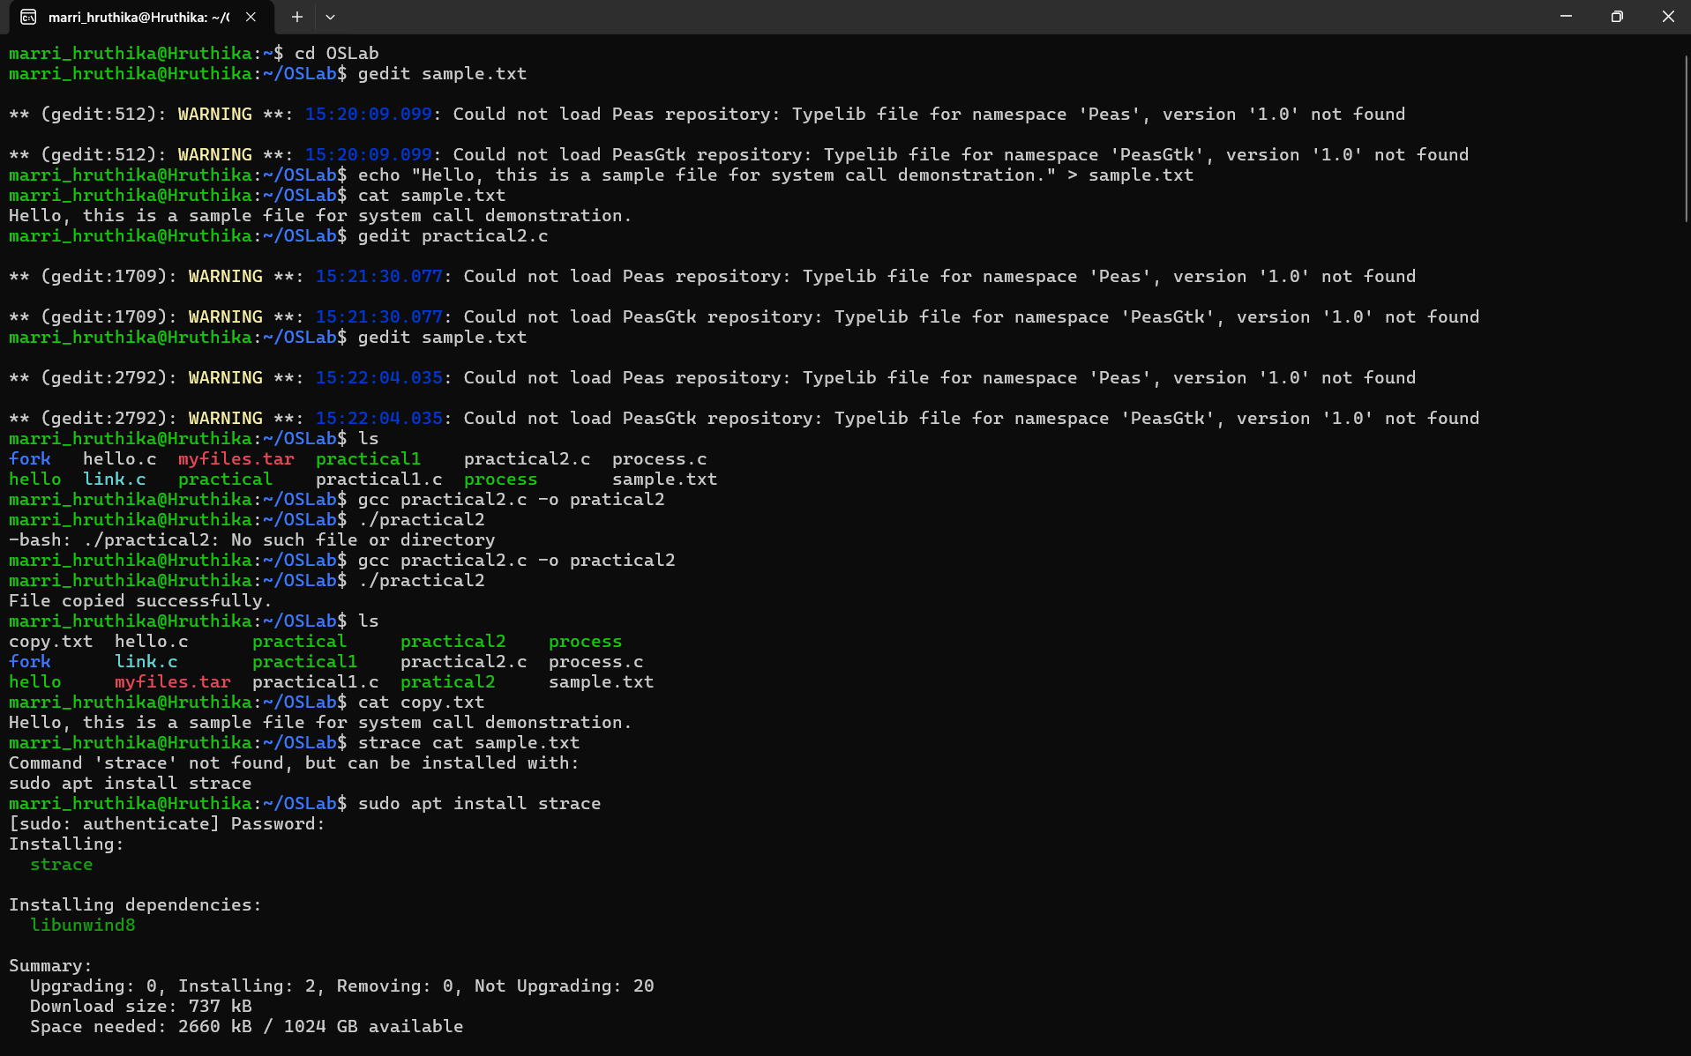
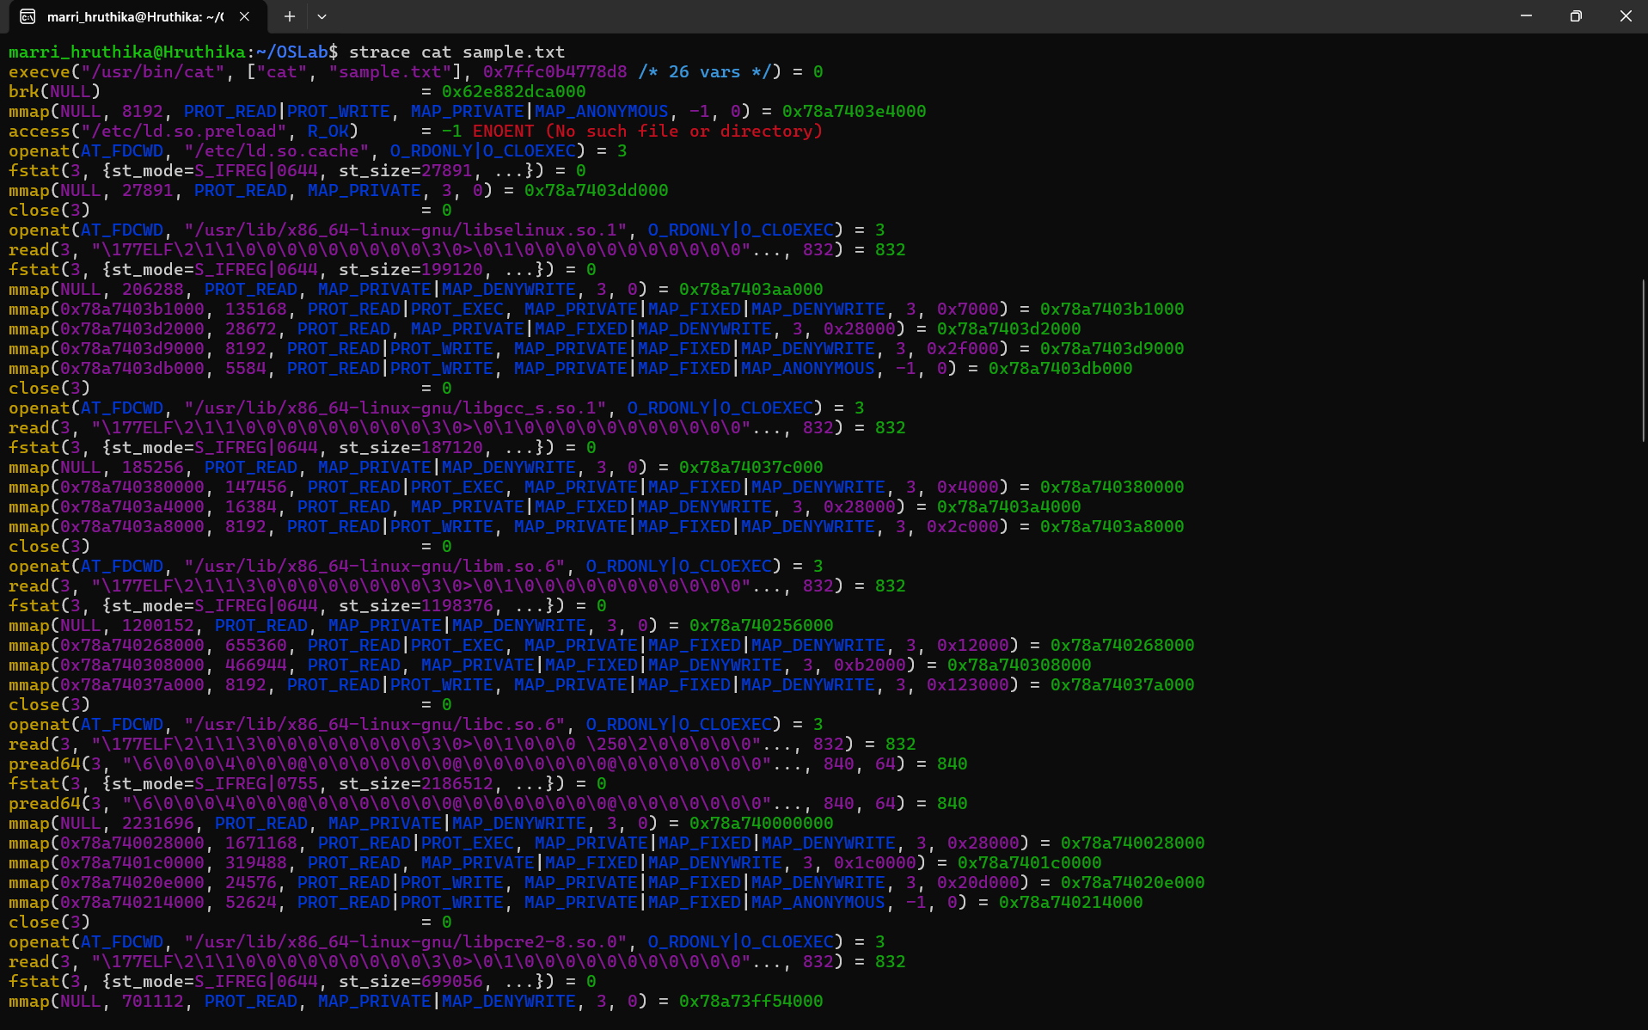
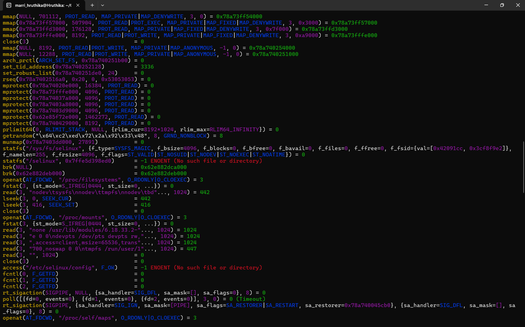
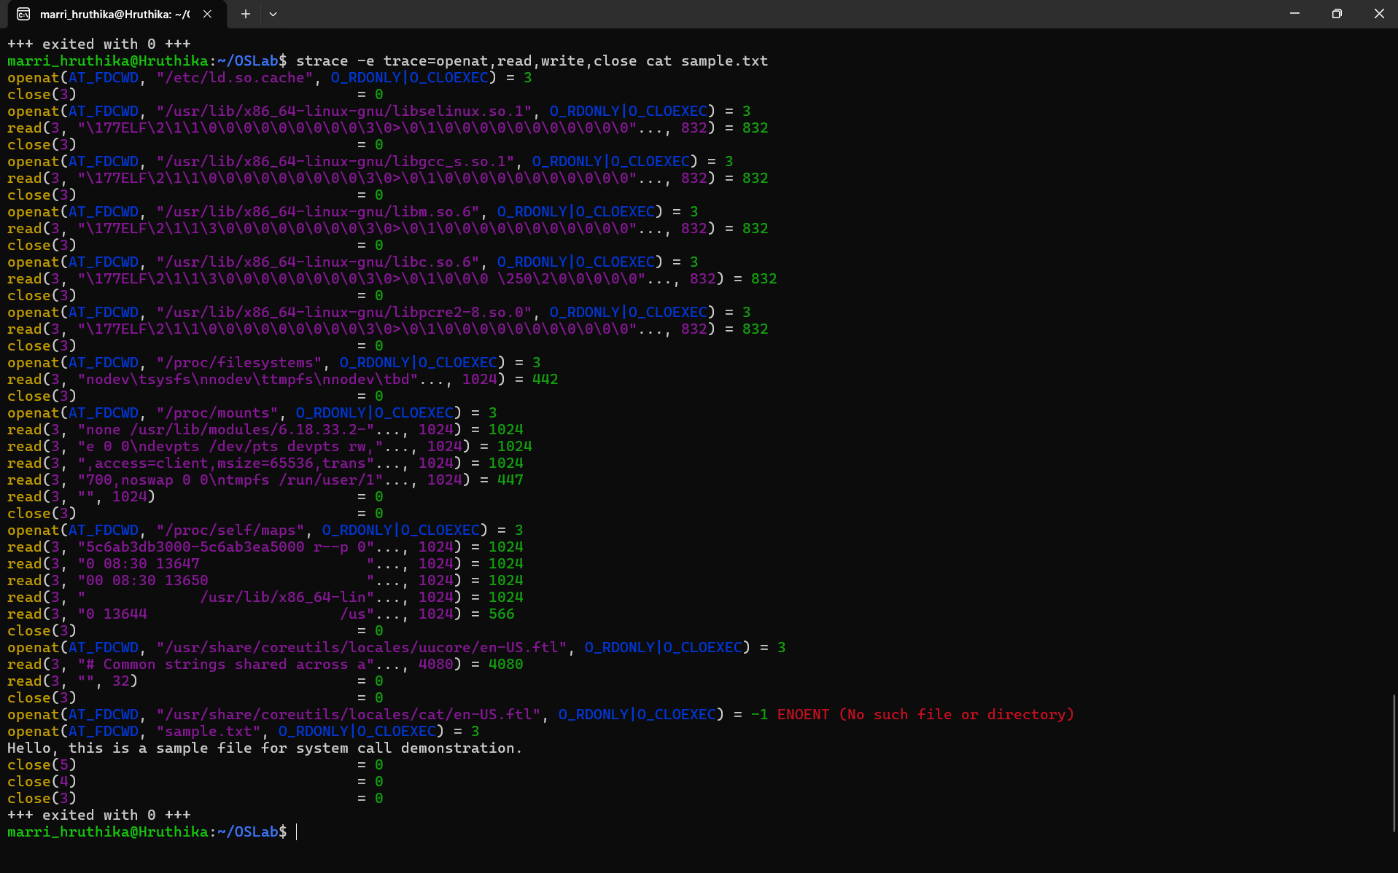

System calls provide an interface between a user-level program and the Linux kernel. In this practical, the C program uses open(), read(), write(), and close() system calls to copy the contents of one file to another. The open() system call opens the source and destination files and returns file descriptors. The read() system call reads data from the source file into a buffer, while write() transfers the data from the buffer to the destination file. After the copying is completed, close() releases the file descriptors. Normally, the program runs in user space, but whenever a system call is made, control temporarily transitions to kernel space, where the kernel performs the requested file or I/O operation and then returns control to the user program. The strace utility is used to observe these system calls. When strace cat sample.txt is executed, calls such as openat(), read(), write(), and close() can be observed. Thus, this practical demonstrates how user programs communicate with the Linux kernel to perform file operations and how system calls can be traced during program execution.

